**Execute OVER and PARTITION BY Clause in SQL Queries**

Partition by is grouping your data based on a specific category and Over by is about the calculation. In the SQL Partition by expression is a subclauses of over clause which is used in performing the aggregation functions like max(), min(), avg() .

In this Example we are creating a Table data name ‘**COURSE’**

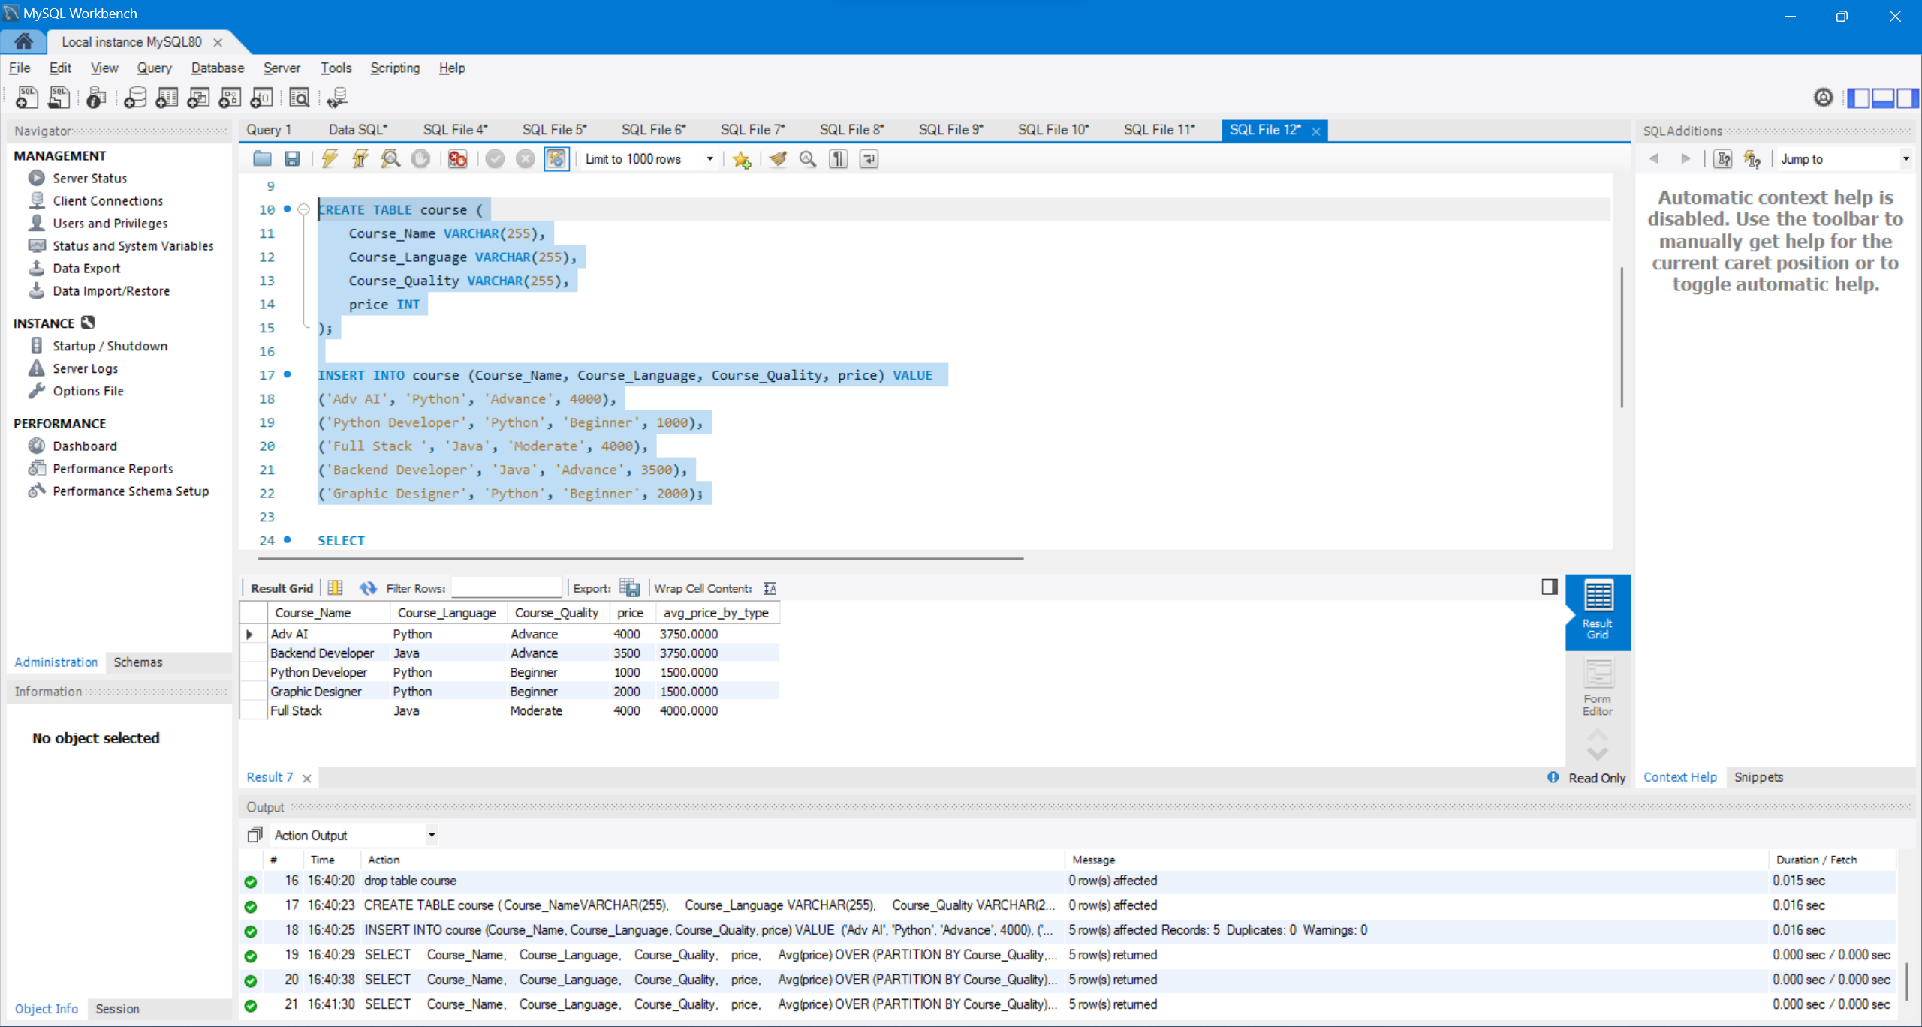

And We are returning the price of each category by using the partition by and Over Clauses

**CODE:**

SELECT

Course_Name,

Course_Language,

Course_Quality,

price,

Avg(price) OVER (PARTITION BY Course_Quality) AS avg_price_by_type

FROM

course;

**OUTPUT:**

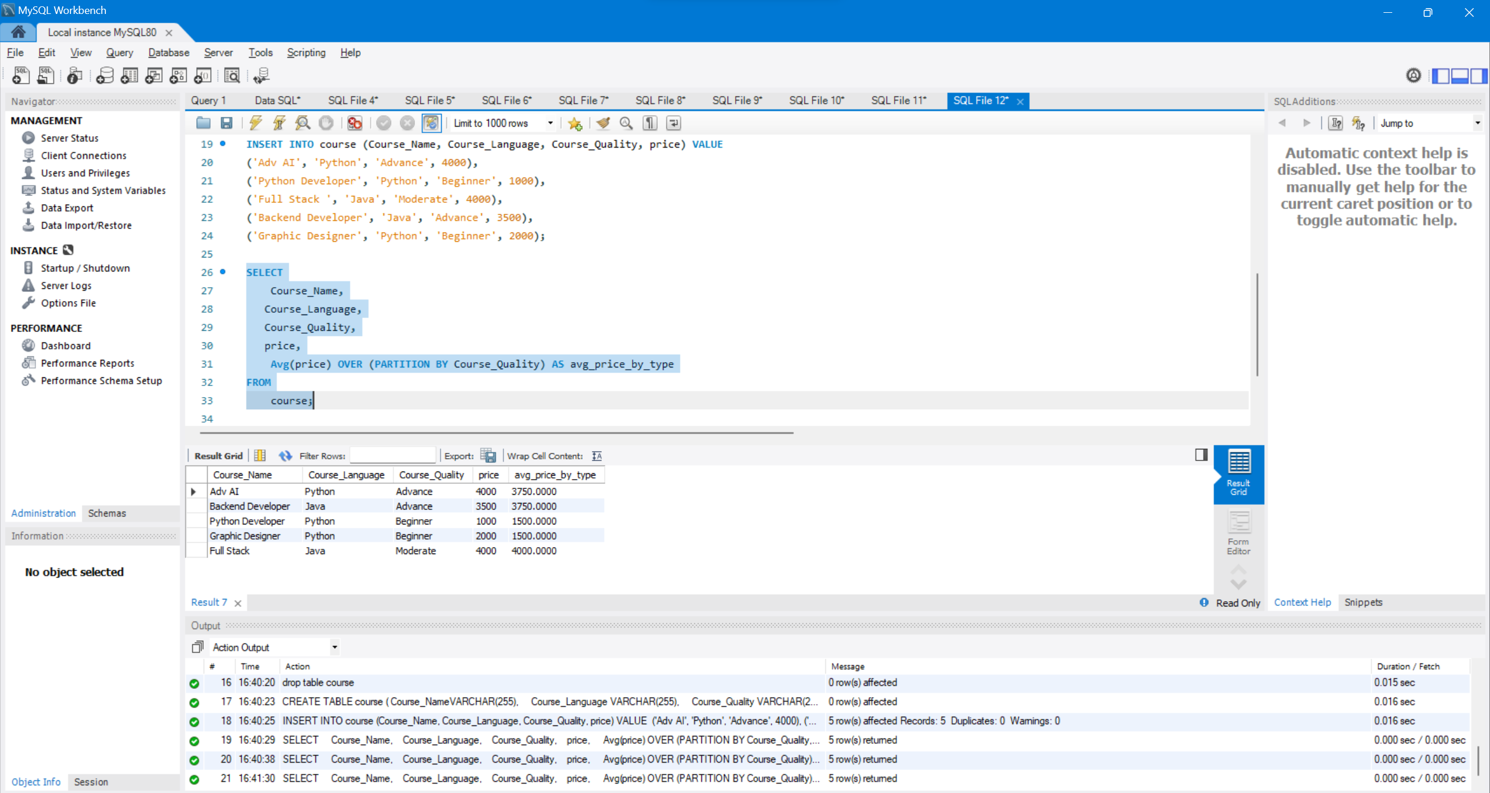

In this example we can clearly see that average price is calculated by course quality attribute.